Jeff Rainwater (aka Reinwasser)

February 2017 Wyoming Wanderings
By Rev. Jeff Rainwater, Wyoming District Superintendent
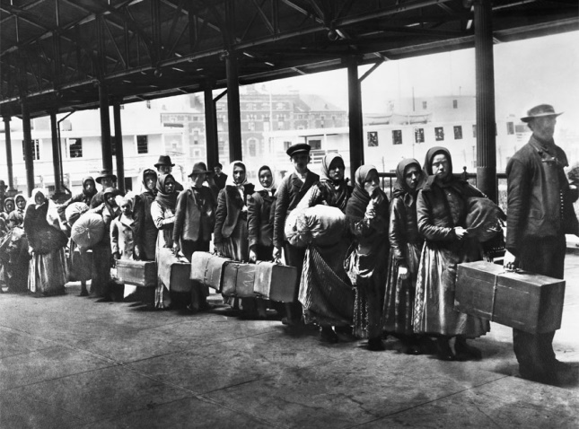
I have a relatively unique last name... Rainwater. Unique names are often conversation starters. I can't count the number of introductions that have followed with, "Rainwater, what a nice name... are you Native American?" This is followed by my usual response, "No, not in my case. My name was actually German once. My ancestors changed it to English when they came to America. It used to be Reinwasser or something like that." And that is often where the conversation stops. Only recently has a question come to my mind, "Why did my ancestors change their name?" Changing one's name is not trivial. There is a lot that relates to a name -- a history, a set of customs, a culture.

We believe they came in the mid-1800s during the large German migration of that era. Did the Reinwasser's (or something like that) face some difficulties because of that German name? Were they not welcome with that German name? Was it easier to find work with the English version of their name? Were there a few more doors opened to them in the American landscape with the new name? Then I began to wonder, what would my life be like today if I was still named Reinwasser (or something like that)? Would all the opportunities afforded me have been there? Would our neighbors have treated us any differently?

The point of sharing this exercise in imagination is that all of us of African, Asian, Pacific Islander, Middle Eastern, or European descent have a story in our past of coming to this great land and finding it already occupied, often by a people of another language or culture. The Reinwasser's may not have found it difficult to be the family with the funny name, the strange language, the different colored skin. But many families did face such struggle, even persecution. That story is likely my story and your story. Many of us just don't know it. How might we better understand and love the stranger, the immigrant, the refugee, the "new guy or girl" as Jesus has commanded us if we better understood our story -- our common story.

This March 4, at our Wyoming District Conference, we are going to ask similar questions as Pastor AJ Bush and Samantha Gupta facilitate an important conversation on finding common ground and loving our neighbors even amid great division we see in our land today. I hope you will plan to attend this event in Lander, Wyoming, and join the conversation. You can register online at our Wyoming District website (wyomingsubdistrict.weebly.com). Whether you can come or not, I hope you will check out Pastor AJ Bush's blog post to learn more (http://pioneeringspirit.org/index.php/2016/12/27/welcoming-the-stranger/).

