Rocky Mountain Conference Quiet Disciple Award
Sponsored by the Rocky Mountain Conference Board of Lay Ministry
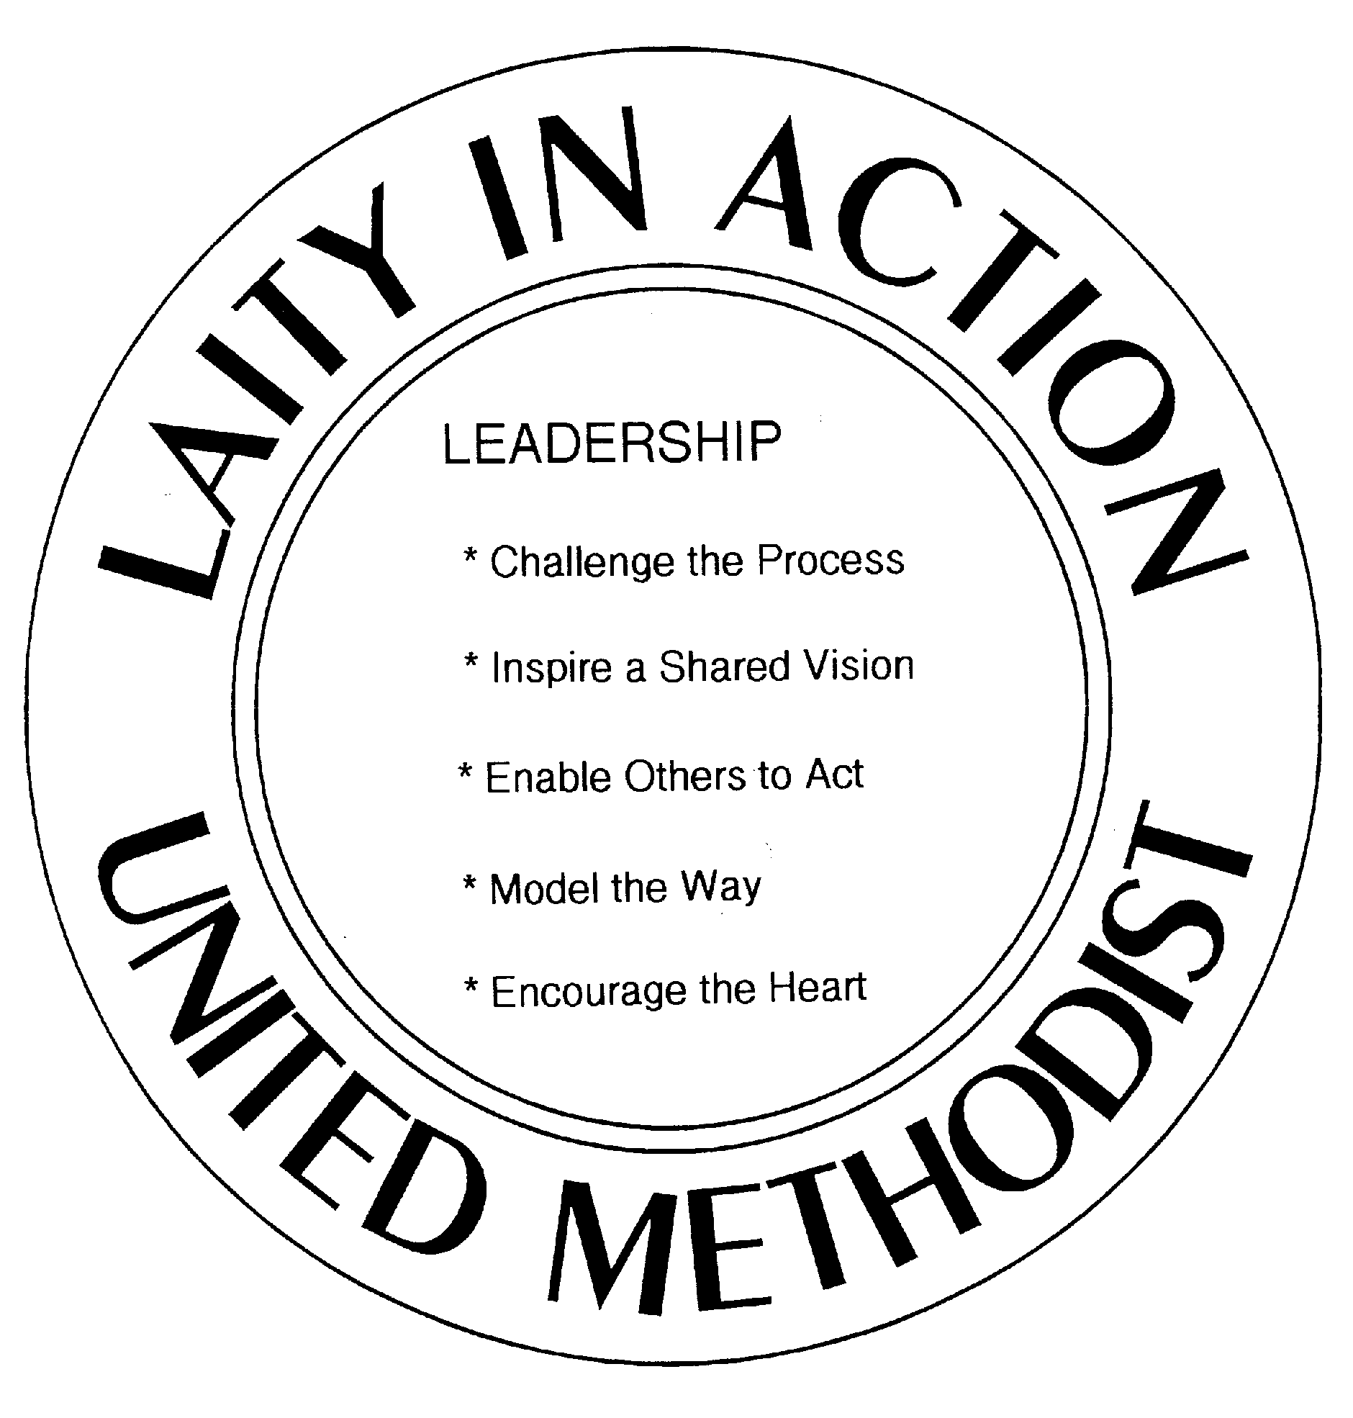

Quiet Disciple Nomination Form
The following church wishes to nominate a deserving laity for the honor of “Quiet Disciple,” from among its parishioners.
Church Name: FIRST UNITED METHODIST CHURCH, NEWCASTLE
Church Mailing Address: P.O. BOX 579 23 N. SENECA
City, State & Zip Code: NEWCASTLE, WYOMING 82701
E-mail address: fumc@fumcnewcastle.com
In recognition of exemplary service to our local congregation, we wish to nominate the following individual for possible selection as the District/Sub-District Recipient of the Quiet Disciple Award.
Nominees Name: MAXINE GRONER
Nominees Mailing Address: 110 S. SUMNER AVE.
City, State & Zip Code: NEWCASTLE, WYOMING 82701
E-mail Address: groner@rtconnect.net
Please accept the following text as our nomination* (must not to exceed 150 words):

“Angel soaring over community…” reads the lead line in the Newsletter Journal. There are angels among us who quietly listen and watch, and then take action to help when needed. These words describe FUMC’s choice for Quiet Disciple, Maxine Groner, who was recently nominated as Newcastle’s Person of the Year.
Whenever or wherever there is a need, Maxine is there. She greets everyone with hugs and lots of smiles and is always genuinely happy to see you and is willing to be involved. Wearing many hats, Maxine performs silent acts of Christian Ministry throughout the community. She is an all-around caregiver.

As a hair expert, she ministers to many of her customers, often making house calls and will end up scrubbing their floors while a perm is processing. Maxine is an awesome Methodist cook, serving in the church kitchen and she has also (at her own expense) done huge Thanksgiving Dinners, inviting anyone! She is a volunteer at the Weston County Manor working with seniors, drives people to and from appointments, visits shut-ins regularly, serves on the Community Concert Board, has served on many Church committees and has been a loyal member of FUMC for nearly half a century!

Maxine is a faithful servant who truly epitomizes the idea of living one’s faith daily.

